**CHAPTER-1**

**INTRODUCTION**

Now days, E-commerce website are very popular. Online shopping Websites plays a major part some of them are Flipkart, Amazon etc., and these websites are requesting (or) accessing will be varied based on the timings. For suppose Monday to Friday will get approximately 10,000 requests. On weekends will get 50,000 requests and also on festivals, offers and also big billion day, in these timings will get lakhs of lakhs request. For this website, we have to maintain servers, applications, storage, etc. On weekends load will be normally so it may require to manage 2 or 3 servers. On weekends we require 10 to 100 servers. On offer’s day we have to maintain thousands of servers. Again, we have to buy more servers compare to all others days infrastructure. In normal days we don’t require this much of servers, applications, and storage. This much of infra of websites building and managing, It is very difficult.

To overcome this issue, we are moving to cloud. That is AWS Cloud, it is providing a feature called load balancing and Auto scaling. Whatever load is coming to websites, that entire load will be redistributed to all existed servers. When the load is exhausted, to up and run 24x7. AWS increases the servers count, based on the policy. In that policy we have to mention C.P.U percentage. For suppose C.P.U percentage is more than 80% then create 3 more servers and when C.P.U percentage is less than 40% delete the new created servers.

Day by day data is increasing like anything not able to manage with storage clusters like an NFS, SAN, and RAID’S. AWS Database Migration Service helps you migrate databases to AWS quickly and securely.

**1.2 Requirements**

Requirement analysis is a software engineering task that bridges the gap between system level software allocation and software design. It provides system engineer to specify software function and performance indicate software’s interface with the other system elements and establish constraints that software must need.

**1.2.1 Hardware Requirements:**

Processor: t2.micro

RAM: 2GB

HDD: 8GB

**1.2.2 Software Requirements:**

Operating System: Amazon Linux

Application server: Apache

Front end: HTML, CSS, Bootstrap

Backend: Nodejs, MySQL

Cisco Networking Devices (Switch and Router)

**1.2.3 Services and Platforms:**

AWS (VPC, S3,Linux,SSH,Cloud Watch)

Load Balancing

Auto Scaling

When the user hits on a certain URL and if the requests are more then there will be increase in the traffic load. There will be lagging of the site and can’t be accessed and there will be unavailability of the URL for the users. If the load on the webpage is more on Big Billion Days for a shopping cart site, then huge loss to the Commercial Applications. Purchasing of physical servers only for one day sale is waste of money and configuring every server day by day is a difficult task to the administrator. Maintenance of servers is difficult. This much of infra of websites building and managing, it is challenging.

To overcome this issue, we are moving to the cloud. That is AWS CLOUD, and it is providing a feature called load balancing and Auto scaling. So when the load hits on the websites, then automatically virtual servers are created so that entire load will be redistributed to all servers. When the load is exhausted, to up and run 24x7. AWS increases the servers count, based on the policy.

**4.2.1 Use Case Diagram:**

Use case Diagrams represent the functionality of the system from a user’s point of view. Use case focuses on the behaviour of the system from an external point of view.

1. **Use Case:**

Use case describes the behaviour of a system. It is used to structure things in a model. It contains multiple scenarios, each of which describes a sequence of actions that is clear enough for outsiders to understand.

1. **Actor:**

An actor represents a coherent set of roles that users of a system play when interacting with the use cases of the system. An actor participates in use cases to accomplish an overall purpose. An actor can represent the role of a human, a device, or any other system.

1. **Description:**

When a commercial client comes to have a deal with an idea for providing the advance maintenance of his data and security policies. He can choose AWS as the better platform. The developer creates web servers to run the commercial website, provides secure login credentials to the user. If the number of users’ increases beyond the range then load balancing and auto-scaling comes up, the average percentage of c.p.u is calculated and allocates the web instances and remove the instances when the percentage goes down.

**Use Case View**

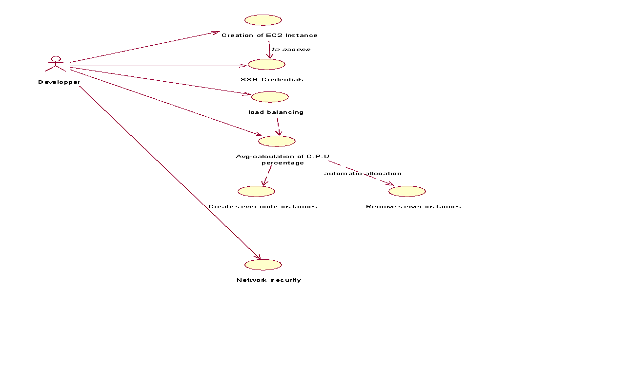**Fig 4.1: Use case view**

**4.2.2Activity Diagram:**

Activity diagram illustrates the dynamic nature of a system by modelling the flow of control from activity. An activity represents an operation on some class in the system that results in a change in the state of the system. Typically, activity diagrams are used to model workflow and internal operation.

Action state represents the no interruptible actions of objects. Action flow represents arrows illustrate the relationships among action states.

**4.2.3Sequence Diagram:**

**S**equence diagram describes the pattern of communication among set of interacting objects. An object interacts with other objects by sending messages. The reception of a message by an object triggers the execution of an operation, which in many turns may send messages to other objects.

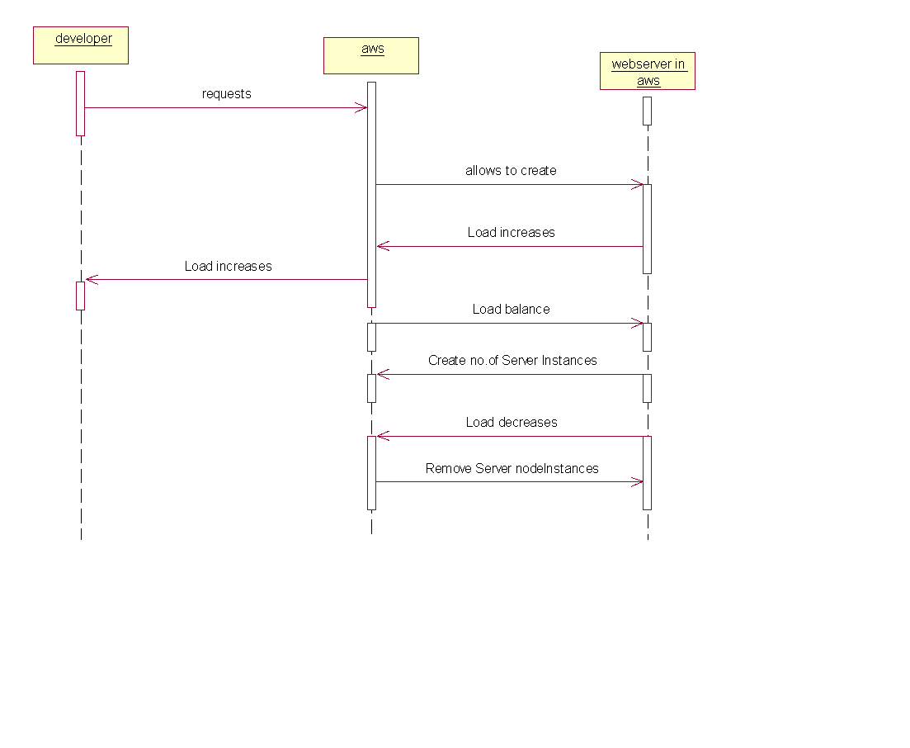

**Fig 4.3: AWS working**

**CHAPTER-2**

**AWS CLOUD**

**Amazon Web Services (AWS):** is owned by Amazon that provides On-demand cloud computing platforms to individuals, companies, and governments, on a paid subscription basis. The technology allows subscribers to have at their disposal a virtual cluster of computers, available at all time through the Internet.

**5.1 Why AWS?**

One of the most successful business cloud platforms is amazon web services, it mainly focus on infrastructure as a service. No other cloud vendor will not defeat Aws cloud. Because it is the first invented, what are all the strategy and concept of technology of Aws, Microsoft azure is doing copy and paste. Aws having highest revenue compare to all other clouds available in market of world. One of most wonderful features is, it supports all programming languages. Those are Dotnet, C#, Python, Shell Scripting, Go. Etc.

Developing, managing, and operating your applications requires a wide variety of technology services. Customers often ask us what represents a fully-functional, flexible technology infrastructure platform. Below, we outline requirements for a modern, robust, industry-leading technology infrastructure platform with all the benefits that the cloud brings to bear. We also provide information about how AWS delivers against these requirements and why you might need each of these capabilities.

AWS began offering its technology infrastructure platform in 2006. At this point, we have over a million active customers using AWS in every imaginable way, and have developed considerable experience operating at scale. We’ve also innovated and delivered at a very rapid pace (delivering 159 significant features and services in 2012, 280 in 2013, 516 in 2014, 722 in 2015, and 1,017 in 2016). Expect this focus on rapidly delivering what customers want to continue.

**5.2 What is Cloud Computing?**

Cloud computing is the on-demand delivery of compute power, database storage ,applications, and other IT resources through a cloud services platform via the internet with pay-as-you-go pricing.

**Cloud Computing Basics**

Whether you are running applications that share photos to millions of mobile users or you’re supporting the critical operations of your business, a cloud services platform provides rapid access to flexible and low-cost IT resources. With cloud computing, you don’t need to make large upfront investments in hardware and spend a lot of time on the heavy lifting of managing that hardware. Instead, you can provision exactly the right type and size of computing resources you need to power your newest bright idea or operate your IT department. You can access as many resources as you need, almost instantly, and only pay for what you use.

**How Does Cloud Computing Work?**

Cloud computing provides a simple way to access servers, storage, databases and a broad set of application services over the Internet. A Cloud services platform such as Amazon Web Services owns and maintains the network-connected hardware required for these application services, while you provision and use what you need via a web application.

* 1. **Cloud computing Type:**

1. Infrastructure as a service

2. Platform as a service

3. Software as a service

5.3.1 **Infrastructure as a service (IAAS):**

Infrastructure as a service (IAAS) is a form of cloud computing that provides virtualized computing resources over the internet. IAAS is one of the three main categories of cloud computing services, alongside software as a service (SAAS) and platform as a service (PAAS).

**IAAS architecture and how it works:**

The IAAS provider also supplies a range of services to accompany those infrastructure components. These can include detailed billing, monitoring, log access, security, load balancing and clustering, as well as storage resiliency, such as backup, replication and recovery. These services are increasingly policy-driven, enabling IAAS users to implement greater levels of automation and orchestration for important infrastructure tasks. For example, a user can implement policies to drive load balancing to maintain application availability and performance.

IAAS customers access resources and services through a wide area network (WAN), such as the internet, and can use the cloud provider's services to install the remaining elements of an application stack. For example, the user can log in to the IAAS platform to create virtual machines (VMs); install operating systems in each VM; deploy middleware, such as databases; create storage buckets for workloads and backups; and install the enterprise workload into that VM. Customers can then use the provider's services to track costs, monitor performance, balance network traffic, troubleshoot application issues, and manage disaster recovery and more. Any cloud computing model requires the participation of a provider. The provider is often a third-party organization that specializes in selling IAAS. Amazon Web Services (AWS) and Google Cloud Platform (GCP) are examples of independent IAAS providers. A business might also opt to deploy a private cloud, becoming its own provider of infrastructure services. Organizations choose IAAS because it is often easier, faster and more cost-efficient to operate a workload without having to buy, manage and support the underlying infrastructure. With IAAS, a business can simply rent or lease that infrastructure from another business.

IAAS is an effective model for workloads that are temporary, experimental or that change unexpectedly. For example, if a business is developing a new software product, it might be more cost-effective to host and test the application using an IAAS provider. Once the new software is tested and refined, the business can remove it from the IAAS environment for a more traditional, in-house deployment. Conversely, the business could commit that piece of software to a long-term IAAS deployment, where the costs of a long-term commitment may be less.

In general, IAAS customers pay on a per use basis, typically by the hour, week or month. Some IAAS providers also charge customers based on the amount of virtual machine space they use. This pay-as-you-go model eliminates the capital expense of deploying in-house hardware and software.

When a business cannot use third-party providers, a private cloud built on premises can still offer the control and scalability of IAAS -- though the cost benefits no longer apply.

5.3.2 **Platform as a service (PAAS):**

Platform as a service (PAAS) is a cloud computing model in which a third-party provider delivers hardware and software tools -- usually those needed for application development -- to users over the internet. A PAAS provider hosts the hardware and software on its own infrastructure. As a result, PAAS frees users from having to install in-house hardware and software to develop or run a new application.

**PAAS architecture and how it works**

PAAS does not typically replace a business's entire IT infrastructure. Instead, a business relies on PAAS providers for key services, such as application hosting or Java development.A PAAS provider builds and supplies a resilient and optimized environment on which users can install applications and data sets. Users can focus on creating and running applications rather than constructing and maintaining the underlying infrastructure and services.Many PAAS products are geared toward software development. These platforms offer compute and storage infrastructure, as well as text editing, version management, compiling and testing services that help developers create new software more quickly andefficiently. A PAAS product can also enable development teams to collaborate and work together, regardless of their physical location.

5.3.3 **Software as a service (SAAS):**

Software as a service (SAAS) is a software distribution model in which a third-party provider hosts application and makes them available to customers over the Internet. SAAS is one of three main categories of cloud computing, alongside infrastructure as a service (IAAS) and platform as a service (PAAS).

SAAS is closely related to the application service provider (ASP) and on demand computing software delivery models. The hosted application management model of SAAS is similar to ASP, where the provider hosts the customer’s software and delivers it to approved end users over the internet. In the software on demand SAAS model, the provider gives customers network-based access to a single copy of an application that the provider created specifically for SAAS distribution. The application’s source code is the same for all customers and when new features or functionalities are rolled out, they are rolled out to all customers. Depending upon the service level agreement (SLA), the customer’s data for each model may be stored locally, in the cloud or both locally and in the cloud. Organizations can integrate SAAS applications with other software using application programming interfaces (APIs). For example, a business can write its own software tools and use the SAAS provider's APIs to integrate those tools with the SAAS offering.

There are SAAS applications for fundamental business technologies, such as email, sales management, customer relationship management (CRM), financial management, human resource management (HRM), billing and collaboration. Leading SAAS providers include Salesforce, Oracle, SAP, Intuit and Microsoft SAAS applications are used by a range of IT professionals and business users, as well as C-level executives.

* 1. **Advantages and Benefits of Cloud Computing**

**1.Trade capital expense for variable expense:** Instead of having to invest heavily in data centres and servers before you know how you’re going to use them, you can only pay when you consume computing resources, and only pay for how much you consume.

**2. Benefit from massive economies of scale**

By using cloud computing, you can achieve a lower variable cost than you can get on your own. Because usage from hundreds of thousands of customers are aggregated in the cloud, providers such as Amazon Web Services can achieve higher economies of scale which translates into lower pay as you go prices.

**3. Stop guessing capacity**

Eliminate guessing on your infrastructure capacity needs. When you make a capacity decision prior to deploying an application, you often either end up sitting on expensive idle resources or dealing with limited capacity. With cloud computing, these problems go away. You can access as much or as little as you need, and scale up and down as required with only a few minutes’ notice.

**4. Increase speed and agility**

In a cloud computing environment, new IT resources are only ever a click away, which means you reduce the time it takes to make those resources available to your developers from weeks to just minutes. This results in a dramatic increase in agility for the organization, since the cost and time it takes to experiment and develop is significantly lower.

1. **Stop spending money on running and maintaining data centres**

Focus on projects that differentiate your business, not the infrastructure. Cloud computing lets you focus on your own customers, rather than on the heavy lifting of racking, stacking and powering servers.